**Build & Deployment:**

**Build/Export/Package:**

**The Process of packaging all the rules in to a Zip file is called build**

**-  In PRPC we call it as a Package.. After adding Package PRPC will generate Product Rule. From Product rule we can generate Product File ( Zip File in Jar Format)**

**Build: we package all the rules into a single file. Packaging is exporting.**

**Build File we call as Product File(Zip File).**

**Step1: Create a Package using Packaging Wizard**

**Step2: It Creates Product Rule, Open Product Rule**

**Step3: Create a Product file from Product rule ( Jar File)**

**Deployment: Importing Product file on the Target environment is called Deployment.**

**To Generate Product File PRPC Provides a Wizard called Packaging Wizard.**

**Package will generate Product Rule.**

**Product rule will generate Product File**

**Using Packaging Wizard to generate Product Rule:**

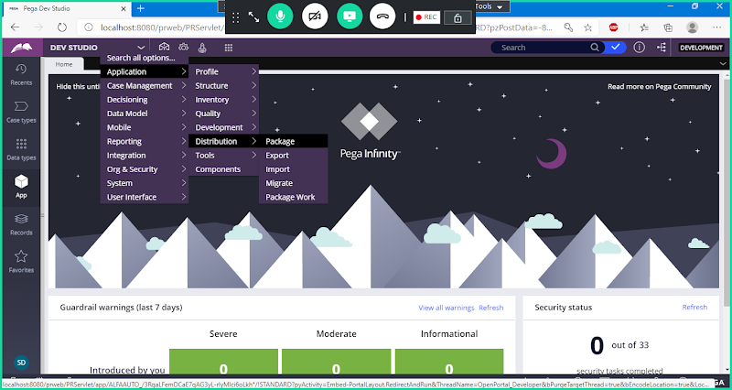

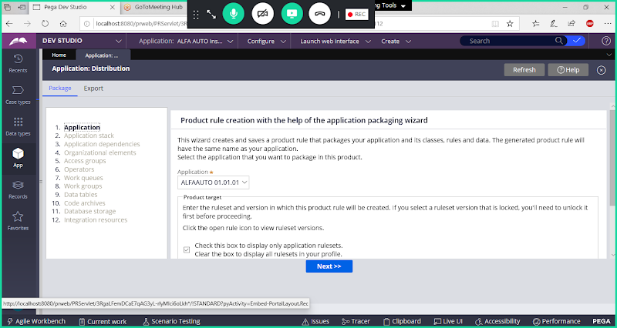

**In step 1 Scroll Down**

**Add Rule Set Name & Version**

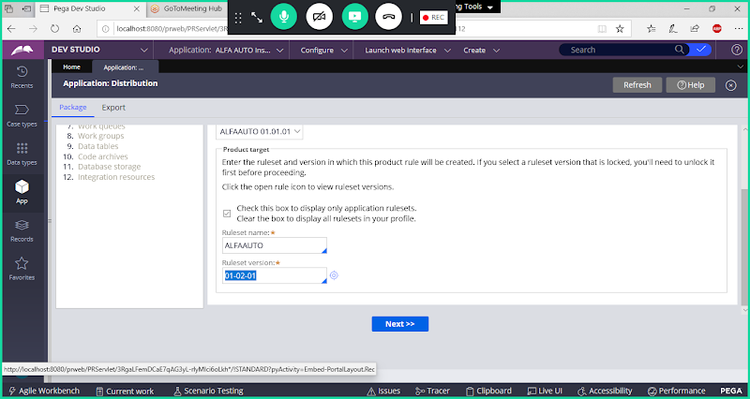

**Next**

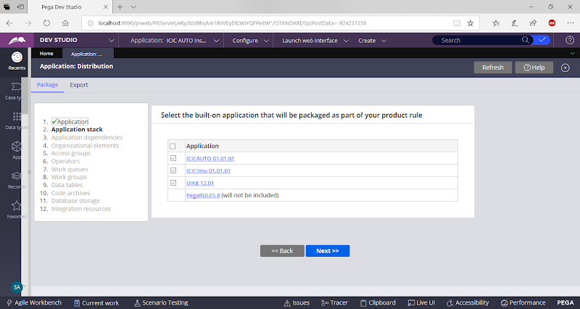

**Next**

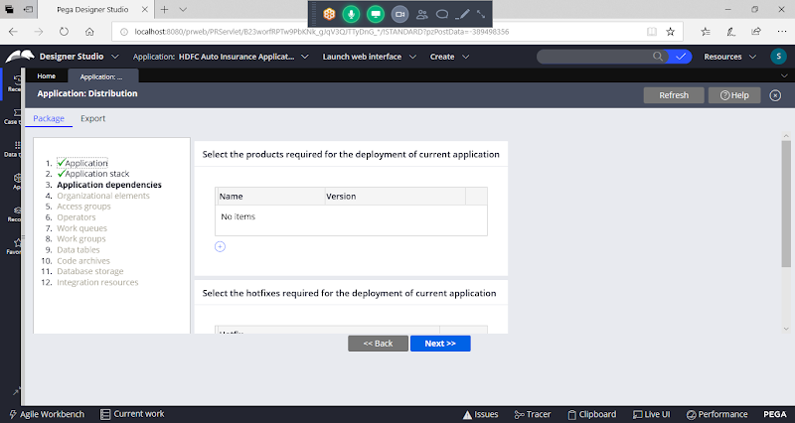

**Next**

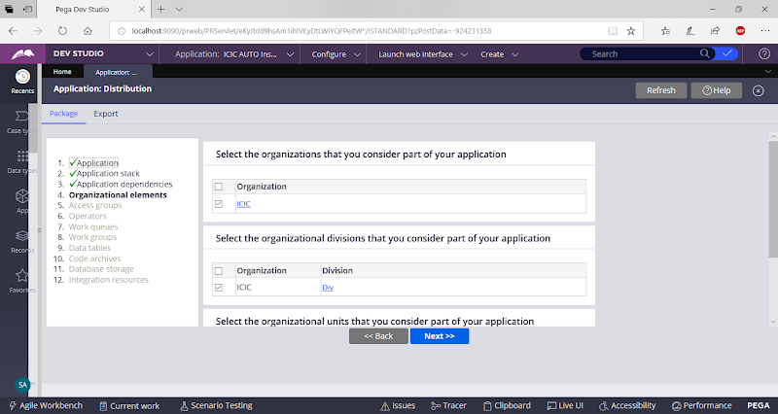

**Next**

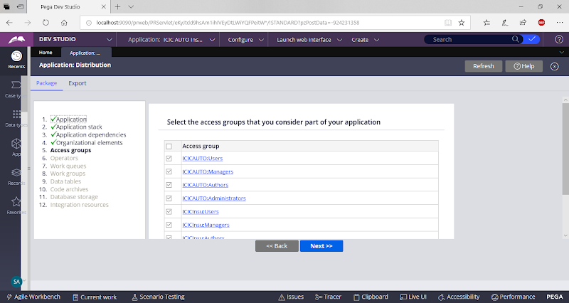

**Next**

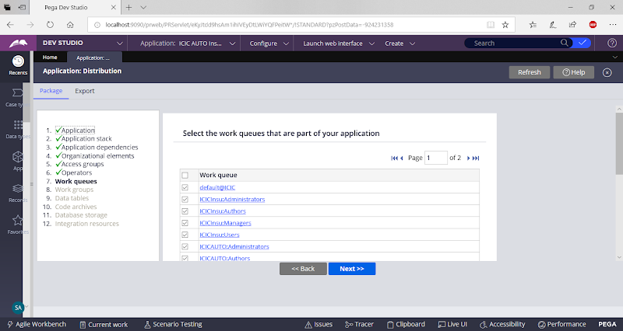

**Next**

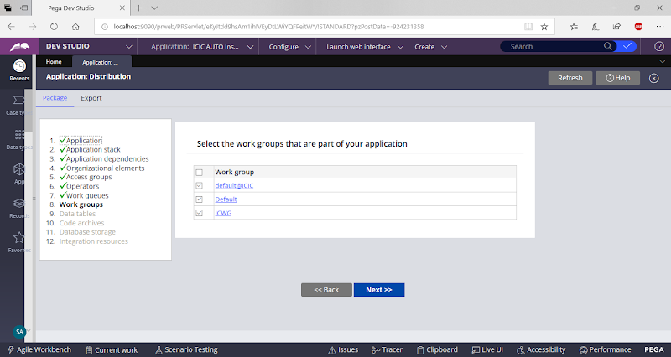

**Next**

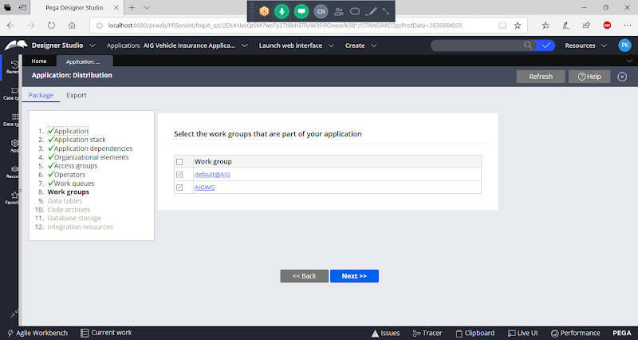

**Next**

**Enable all Tables & Click on Next**

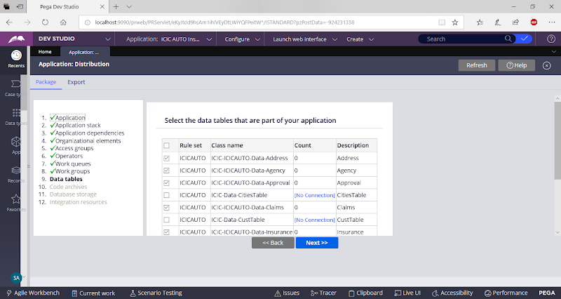

**Next**

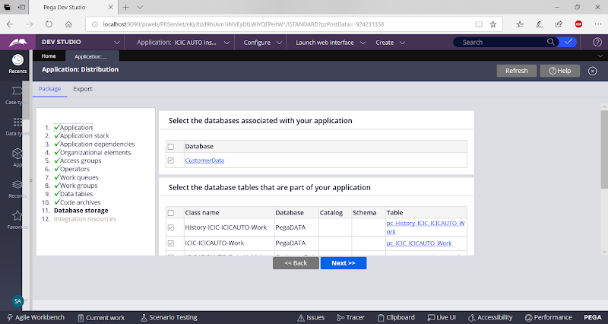

**Next**

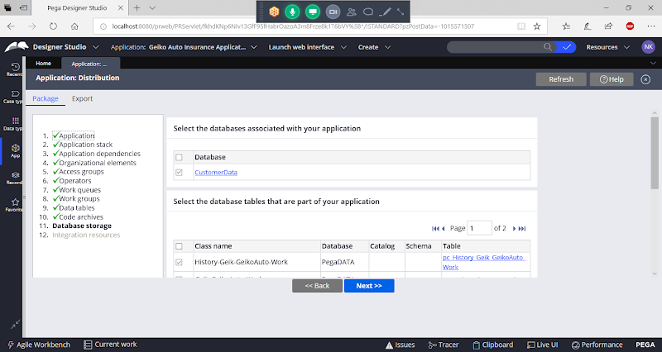

**Next**

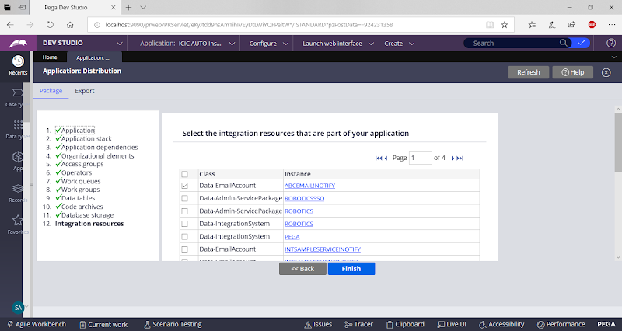

**Click on Finish**

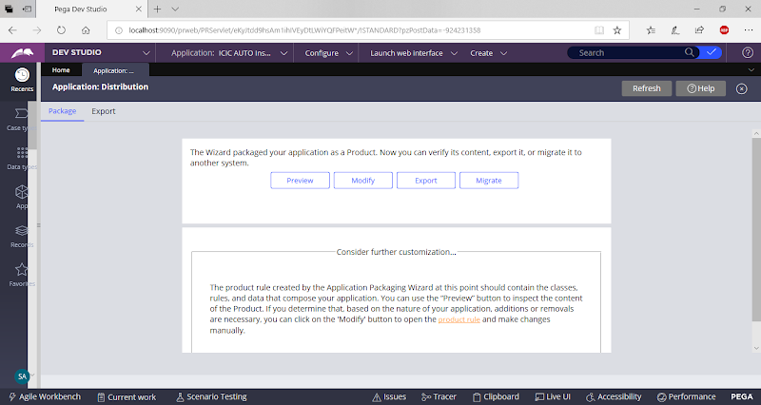

**Open Product Rule from Product Rule Link**

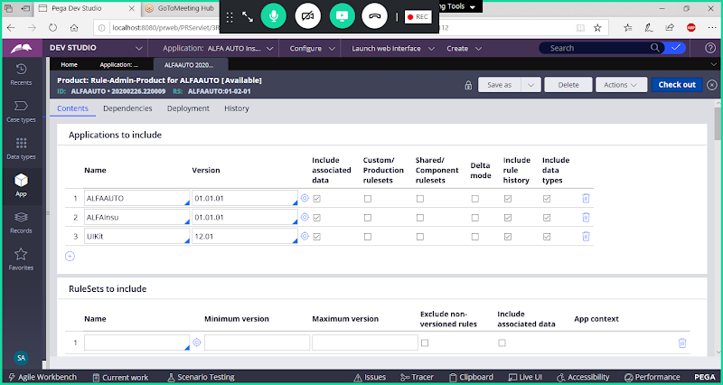

**Manually add Ruleset Name:  Add Ur Application Ruleset**

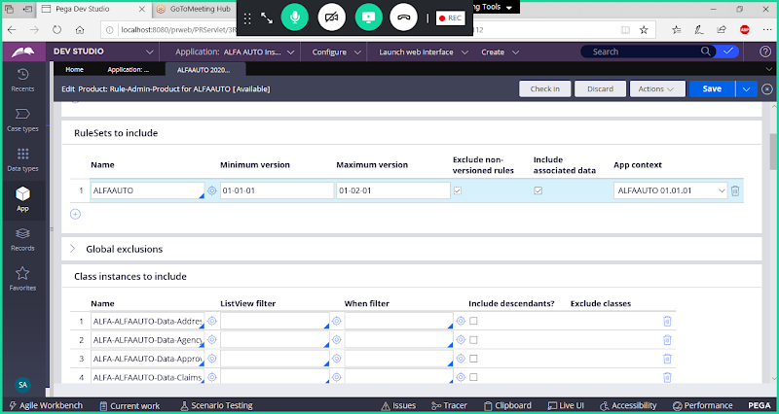

**Scroll down in the Product Rule:**

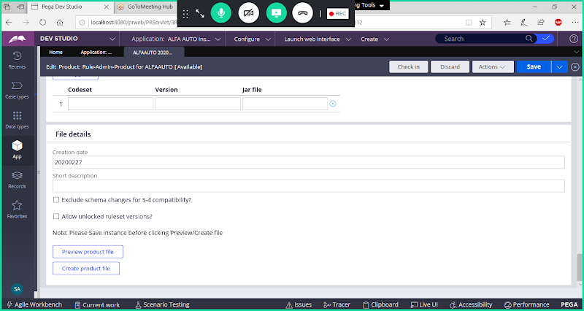

**Add Description & Enable : Allow unlocked Ruleset Versions**

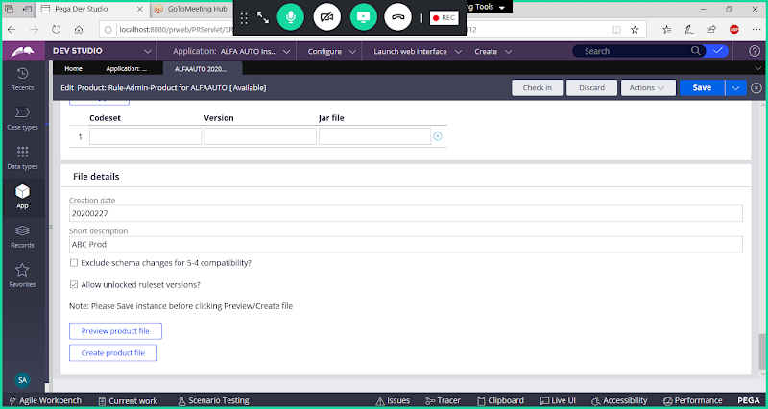

**Save Product Rule & Check in**

**Now Click on Create Product File button.**

**Give Name & Click on Ok**

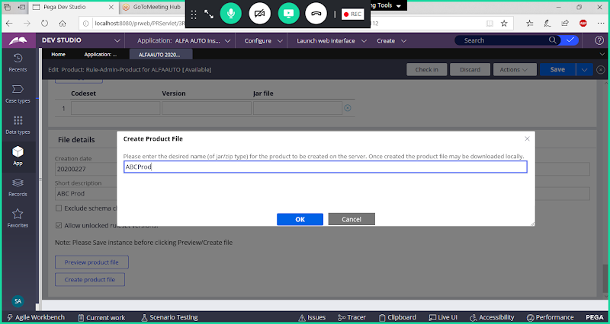

**Click on OK**

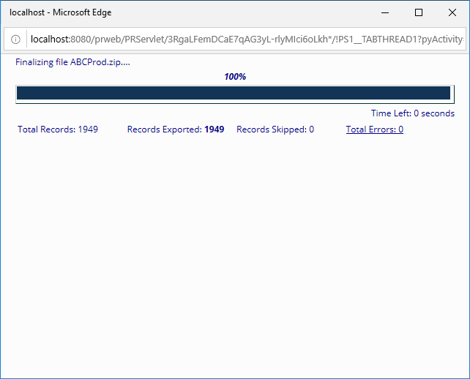

**Save the File to your local system.**

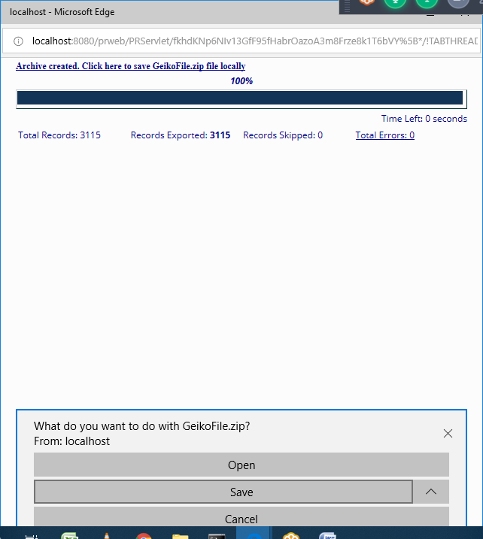

**Click on Save.**

**How to Import the File:**

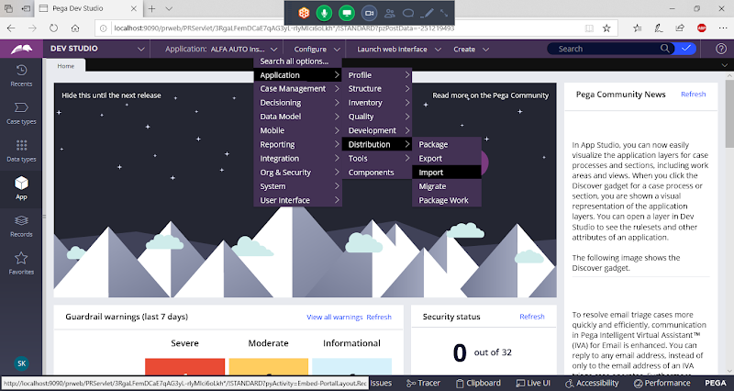

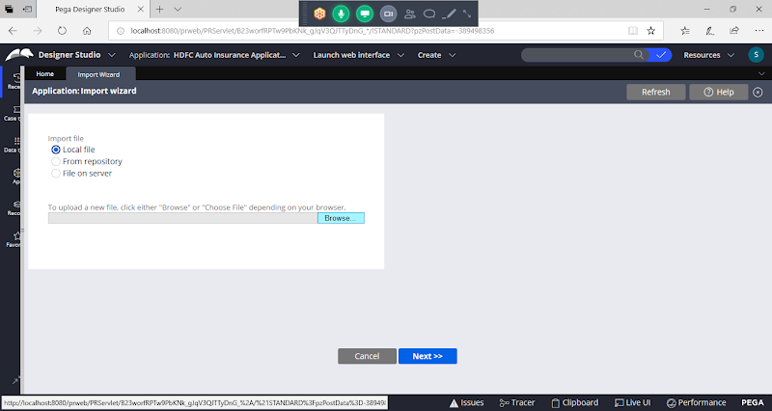

**Choose File & Follow the steps to import the file.**

**---------------**

**In Personal Edition to Take the Backup follow below steps:**

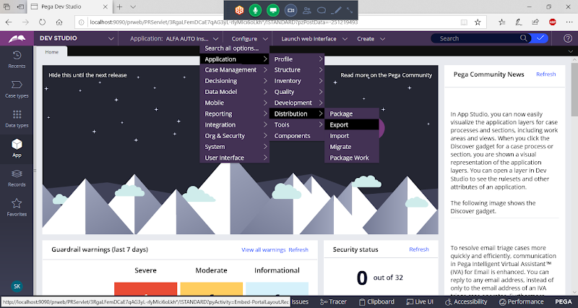

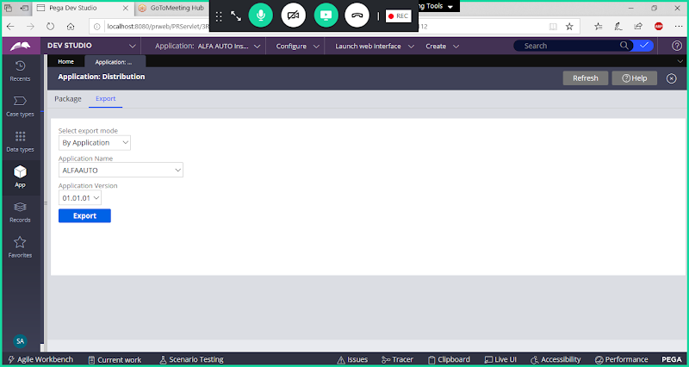

**Select Framework Application First:**

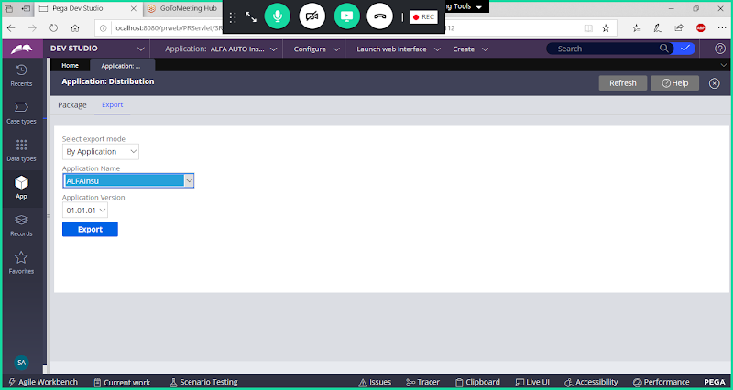

**Click on Export**

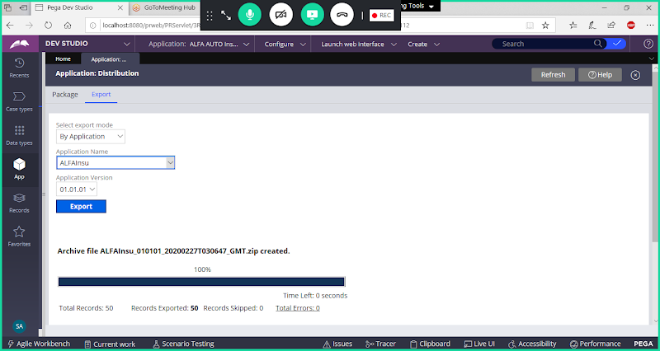

**Now Export Implementation Application:**

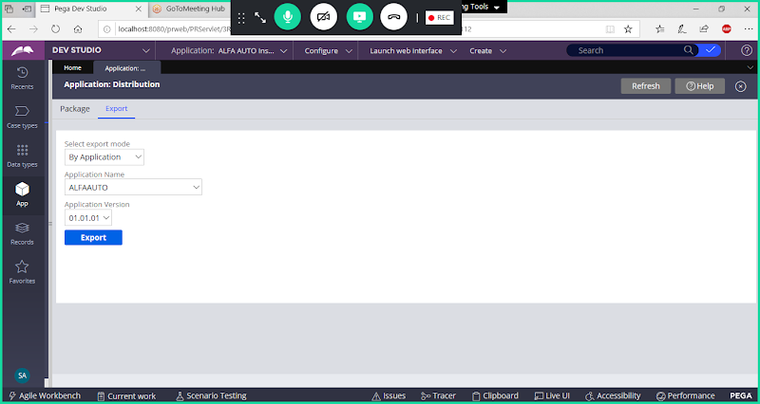

**Click on Export**

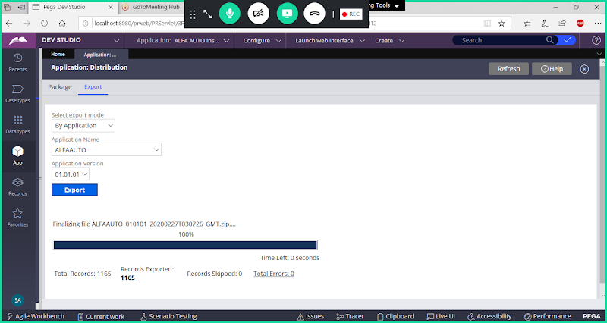

**If you want to Import the Application first Import Framework Application & Then Import Implementation Application.**